**Supplementary Materials**

**Exploring dynamics of RNA molecules with multiscale Gaussian network model**

Shihao Wang, Weikang Gong, Xueqing Deng, Yang Liu, Chunhua Li*

College of Life Science and Bioengineering, Beijing University of Technology, Beijing 100124, China

*All correspondence should be addressed to Chunhua Li (E-mail: [chunhuali@bjut.edu.cn](mailto:chunhuali@bjut.edu.cn))

Table S1. 77 RNAs in the dataset constructed by us and their PCC values obtained by the three GNM methods

|  |  |  |  |  |  |
| --- | --- | --- | --- | --- | --- |
| PDB ID | Number of nucleotides | Description | PCC values | | |
| GNM | pfGNM | mGNM |
| 1D4R | 87 | 29-mer fragment of human srp RNA helix 6 | 0.132 | 0.069 | 0.814 |
| 1DDY | 140 | Molecular recognition by the vitamin b12 RNA aptamer | 0.639 | 0.668 | 0.715 |
| 1DUQ | 104 | rev binding element of HIV-1 | 0.187 | 0.016 | 0.642 |
| 1KXK | 70 | RNA molecule containing domain 5 and 6 of the yeast ai5g group ii self-splicing intron | 0.221 | -0.208 | 0.798 |
| 1NUJ | 96 | The leadzyme structure | 0.184 | 0.104 | 0.546 |
| 1Q93 | 81 | mutant of the sarcin/ricin domain from rat 28S rRNA | 0.551 | -0.057 | 0.733 |
| 1QBP | 90 | brominated RNA helix with four mismatched base pairs | 0.707 | 0.210 | 0.731 |
| 1T0D | 66 | 2-aminopurine labelled bacterial decoding site RNA | 0.184 | 0.134 | 0.646 |
| 1U9S | 161 | specificity domain of ribonuclease P of the A-type | 0.585 | 0.433 | 0.696 |
| 1VTQ | 75 | yeast tRNAasp | 0.952 | -0.046 | 0.998 |
| 1Y26 | 71 | A-riboswitch | 0.721 | 0.608 | 0.756 |
| 1Y27 | 68 | G-riboswitch | 0.236 | -0.195 | 0.813 |
| 1YLS | 98 | selenium-modified Diels-Alder ribozyme complexed with the product of the reaction between N-pentylmaleimide and covalently attached 9-hydroxymethylanthracene | 0.206 | 0.046 | 0.557 |
| 1Z43 | 101 | 7S.S SRP RNA of M. jannaschii | 0.354 | -0.070 | 0.689 |
| 1ZX7 | 116 | Molecular recognition | 0.260 | 0.199 | 0.589 |
| 2CKY | 154 | Arabidopsis thaliana thiamine pyrophosphate riboswitch with its regulatory ligand | 0.471 | 0.334 | 0.632 |
| 2GCS | 152 | thermoanaerobacter tengcongensis glmS ribozyme | 0.825 | 0.700 | 0.816 |
| 2GDI | 160 | thiamine pyrophosphate-specific riboswitch in complex with thiamine pyrophosphate | 0.095 | -0.013 | 0.535 |
| 2GIS | 94 | S-adenosylmethionine riboswitch mRNA regulatory element | 0.457 | 0.412 | 0.733 |
| 2NOK | 88 | RNA domain from Hepatitis C virus | 0.423 | 0.384 | 0.780 |
| 2OEU | 63 | hammerhead ribozyme with Mn(II) bound | 0.257 | -0.329 | 0.689 |
| 2OIU | 142 | L1 Ribozyme Ligase circular adduct | 0.374 | 0.051 | 0.672 |
| 2QBZ | 161 | M-Box Riboswitch Aptamer Domain | 0.340 | 0.329 | 0.717 |
| 2QUS | 138 | Hammerhead Ribozyme G12A mutant pre-cleavage | 0.322 | -0.003 | 0.560 |
| 2QWY | 156 | SAM-II riboswitch bound to S-adenosylmethionine | 0.571 | 0.534 | 0.630 |
| 2TRA | 75 | yeast aspartic acid tRNA | 0.563 | 0.318 | 0.763 |
| 2YIE | 111 | F. nucleatum FMN riboswitch bound to FMN | 0.742 | 0.571 | 0.794 |
| 3BNN | 84 | homo sapiens mitochondrial ribosomal decoding site | 0.181 | 0.056 | 0.495 |
| 3BNO | 84 | homo sapiens mitochondrial ribosomal decoding site | 0.188 | 0.112 | 0.592 |
| 3D0U | 161 | Lysine Riboswitch Bound to Lysine | 0.377 | 0.247 | 0.637 |
| 3DS7 | 134 | RNA-2'-deoxyguanosine complex | 0.664 | 0.597 | 0.690 |
| 3FU2 | 102 | class-I preQ1 riboswitch | 0.532 | 0.417 | 0.795 |
| 3IVN | 140 | U65C mutant A-riboswitch aptamer from the Bacillus subtilis pbuE operon | 0.381 | 0.151 | 0.734 |
| 3L0U | 76 | unmodified tRNAPhe from Escherichia coli | 0.261 | 0.229 | 0.834 |
| 3LA5 | 71 | mc6 RNA Riboswitch bound to azacytosine | 0.816 | 0.702 | 0.840 |
| 3OWI | 176 | the glycine riboswitch bound to glycine | 0.618 | 0.482 | 0.706 |
| 3P22 | 196 | viral RNA stability element | 0.180 | 0.075 | 0.667 |
| 3Q3Z | 150 | c-di-GMP-II riboswitch | 0.420 | 0.290 | 0.673 |
| 3RG5 | 172 | Mouse tRNA(Sec) | 0.602 | 0.458 | 0.714 |
| 3SD3 | 89 | tetrahydrofolate riboswitch containing a U25C mutation | 0.426 | 0.341 | 0.762 |
| 3SKI | 136 | 2'- Deoxyguanosine riboswitch bound to 2'-deoxyguanosine | 0.349 | 0.290 | 0.580 |
| 3SUH | 101 | THF riboswitch, bound with 5-formyl-THF | 0.898 | 0.847 | 0.901 |
| 4FRG | 168 | the cobalamin riboswitch | 0.317 | 0.317 | 0.596 |
| 4JF2 | 77 | class II preQ1 riboswitch | 0.468 | 0.275 | 0.754 |
| 4JRC | 114 | Distal Stem I region from G. kaustophilus glyQS T box RNA | 0.848 | 0.590 | 0.886 |
| 4L81 | 96 | SAM-I/IV riboswitch | 0.341 | 0.343 | 0.660 |
| 4P5J | 86 | tRNA-like structure | 0.628 | 0.499 | 0.775 |
| 4P9R | 192 | group I intron | 0.520 | 0.467 | 0.668 |
| 4PQV | 68 | Xrn1-resistant RNA | 0.305 | 0.262 | 0.774 |
| 4QLM | 125 | ydao riboswitch binding to c-di-AMP | 0.757 | 0.700 | 0.795 |
| 4RGE | 168 | the in-line aligned env22 twister ribozyme | 0.530 | 0.398 | 0.732 |
| 4RUM | 94 | NiCo transition-metal riboswitch bound to cobalt | 0.602 | 0.393 | 0.808 |
| 4RZD | 101 | PreQ1 Riboswitch | 0.719 | 0.457 | 0.856 |
| 4TS0 | 91 | Spinach RNA aptamer | 0.699 | 0.633 | 0.769 |
| 4TZX | 71 | Vibrio Vulnificus Adenine Riboswitch variant | 0.714 | 0.655 | 0.765 |
| 4WFL | 107 | complete bacterial SRP Alu domain | 0.619 | 0.449 | 0.852 |
| 4XW7 | 64 | ZMP riboswitch | 0.175 | 0.054 | 0.688 |
| 4Y1M | 200 | Escherichia coli Mn riboswitch | 0.700 | 0.430 | 0.804 |
| 4YAZ | 168 | 3',3'-cGAMP riboswitch bound with 3',3'-cGAMP | 0.484 | 0.439 | 0.577 |
| 4ZNP | 146 | A pfI Riboswitch | 0.621 | 0.637 | 0.861 |
| 5BJO | 72 | Corn RNA aptamer | 0.598 | 0.428 | 0.790 |
| 5BTM | 110 | AUUCU repeating RNA | 0.542 | 0.219 | 0.774 |
| 5BTP | 150 | ZTP riboswitch | 0.824 | 0.734 | 0.872 |
| 5EAO | 68 | the hammerhead ribozyme | 0.238 | 0.210 | 0.645 |
| 5FJ1 | 192 | standard kink turn HmKt-7 as stem loop in P212121 space group | 0.618 | 0.499 | 0.713 |
| 5KPY | 71 | 5-hydroxytryptophan aptamer | 0.746 | 0.611 | 0.882 |
| 5KTJ | 130 | self-cleaving ribozyme | 0.324 | -0.149 | 0.788 |
| 5LYS | 114 | 7SK 5'-hairpin - Gold derivative | 0.900 | 0.738 | 0.943 |
| 5NDI | 80 | E.coli guanidine II riboswitch | 0.210 | -0.301 | 0.502 |
| 5NWQ | 82 | thermobifida fusca guanidine III riboswitch with guanidine | 0.680 | 0.179 | 0.836 |
| 5OB3 | 69 | iSpinach aptamer | 0.841 | 0.746 | 0.909 |
| 5T3K | 66 | ribosomal decoding site | 0.258 | 0.101 | 0.671 |
| 5T83 | 95 | guanidine-I riboswitch from S. acidophilus | 0.649 | 0.631 | 0.799 |
| 5TPY | 71 | an exonuclease resistant RNA from Zika virus | 0.716 | 0.639 | 0.743 |
| 5U3G | 85 | guanidinium | 0.569 | 0.276 | 0.726 |
| 5UNE | 94 | RNA Gene: HAR1 | 0.578 | 0.515 | 0.733 |
| 6C63 | 104 | the Mango-II Fluorescent Aptamer | 0.529 | 0.166 | 0.766 |

Table S2: The average PCC values using pfANM with different inverse powers of inter-residue distance.

|  |  |  |  |  |  |  |  |  |  |
| --- | --- | --- | --- | --- | --- | --- | --- | --- | --- |
| power | 2 | 3 | 4 | 5 | 6 | 7 | 8 | 9 | 10 |
| PCC | 0.321 | 0.319 | 0.318 | 0.316 | 0.311 | 0.303 | 0.294 | 0.287 | 0.282 |

1. (B) (C)

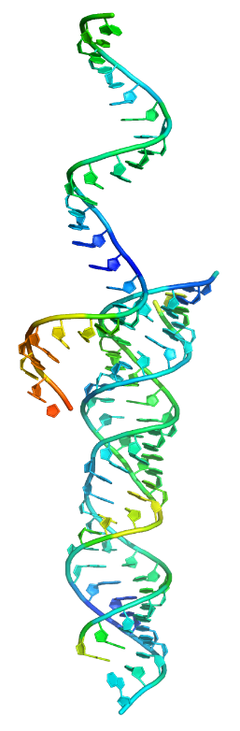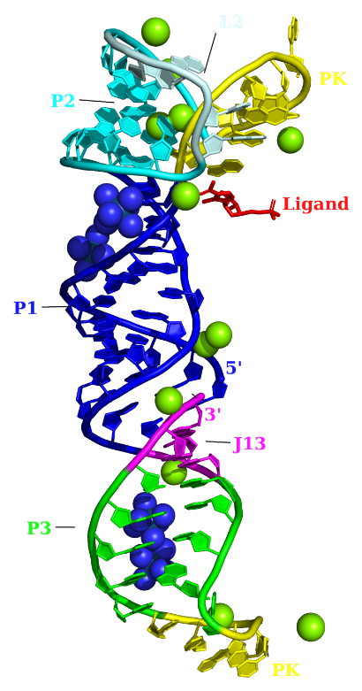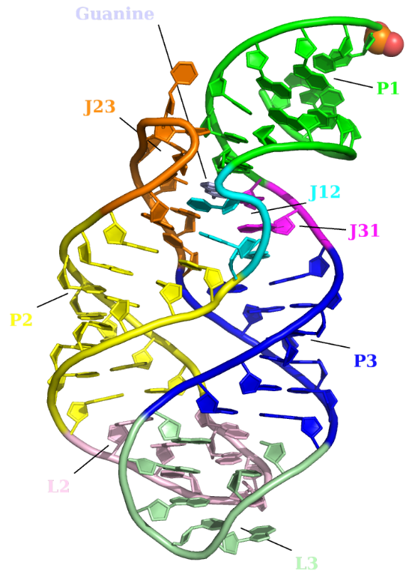

Figure S1. Crystal structures of three RNAs. (A) Fragment of helix 6 of human signal recognition particle (SRP) RNA (PDB ID: 1D4R), (B) ZMP riboswitch (PDB ID: 4XW7), and (C) G-riboswitch-guanine complex (PDB ID: 1Y27) with some main segments labeled with different colors.

Figure S2: The optimization process of parameters *η1, η2 , η3, k1 , k2 ,k3* of mGNM